**BOOTSTRAP**

1. What are the advantages of Bootstrap?

* Consistency
* Responsiveness
* Support
* Speed of Development
* Customizability

1. What is a Bootstrap Container, and how does it work?

* Containers are the most basic layout element in the bootstrap and are required when using our default grid system.

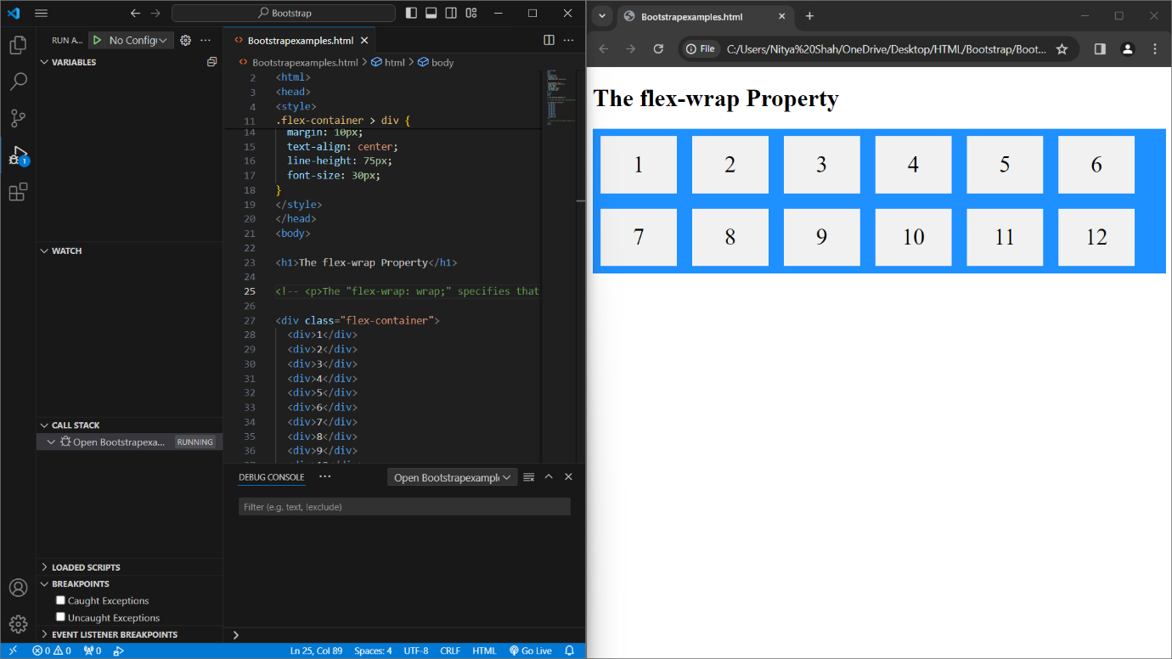

1. What are the default Bootstrap text settings?

* Some of the default Bootstrap text settings are Font family, Font size, Font weight, line height and margin etc.

1. What do you know about the Bootstrap Grid System?

- The CSS Grid Layout Module offers a grid-based layout system, with rows and columns, making it easier to design web pages without having to use floats and positioning.

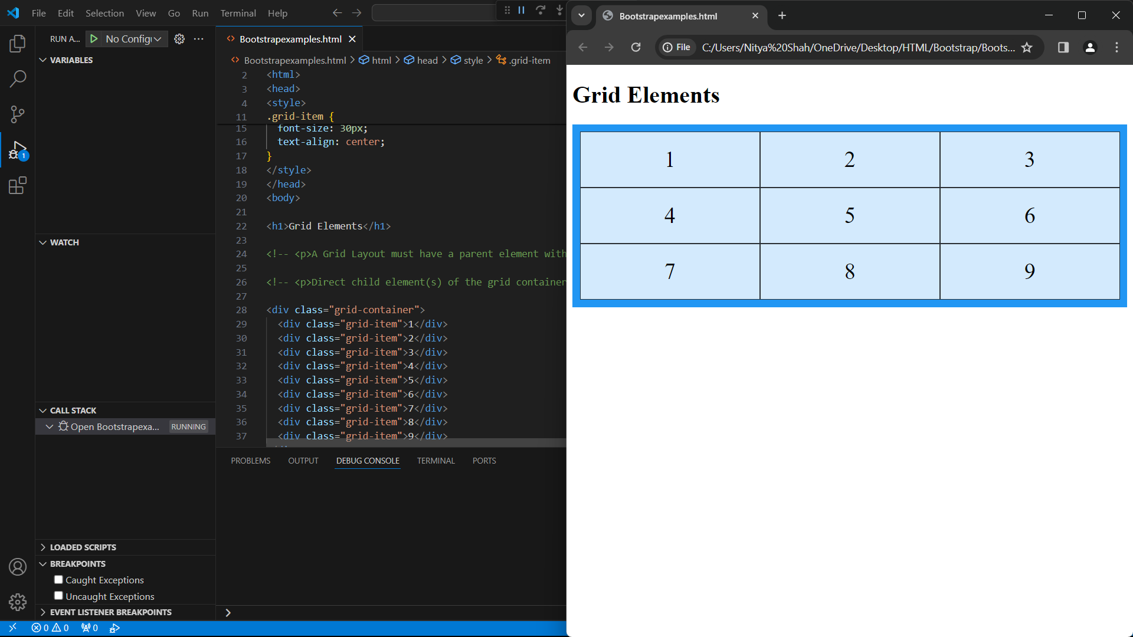

1. What is the difference between Bootstrap 4 and Bootstrap 5?

|  |  |
| --- | --- |
| Bootstrap 4 | Bootstrap 5 |
| It has 5 tier. | It has 6 tier. |
| It supports both IE 10 and 11. | It doesn’t support IE 10 and 11. |
| It has Jquery and all related plugins. | Jquery is removed and switched to vanilla. |
| We cannot modify utilities in Bootstrap4. | Modify and create our own utility. |

1. What is a Button Group, and what is the class for a basic Button Group?

* It is a class of name “btn-group” which is used to create a series of buttons in groups vertically or horizontally.

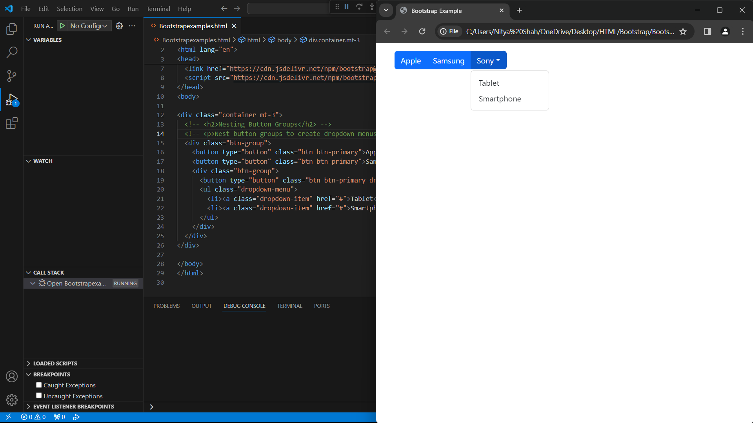

1. How can you use Bootstrap to make thumbnails?

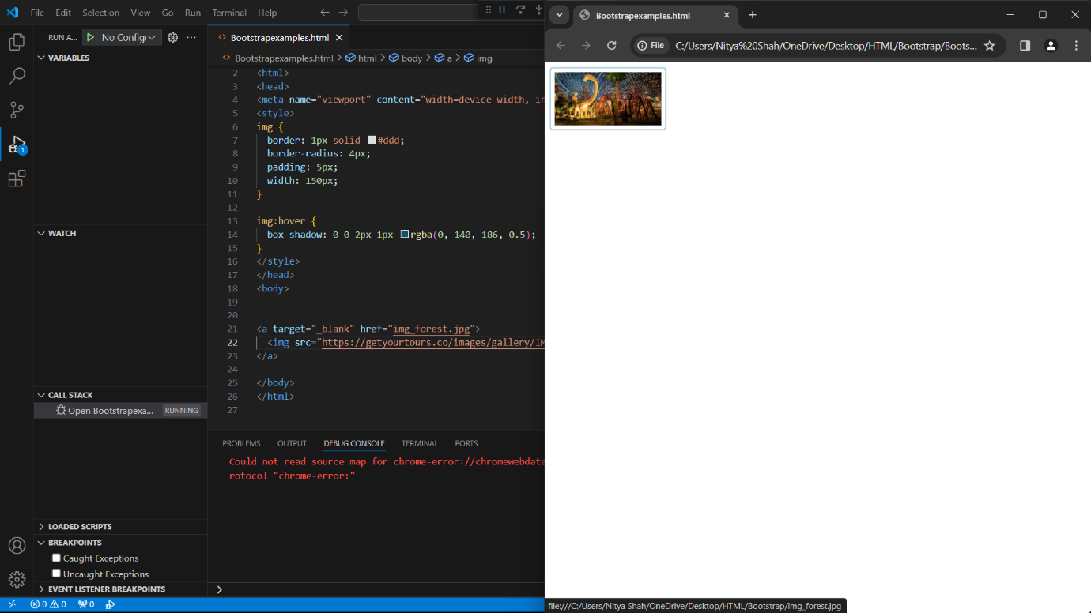

1. In Bootstrap 4, what is flexbox?

* Flexbox is used to control the layout and alignment specification of Bootstrap 4 components.

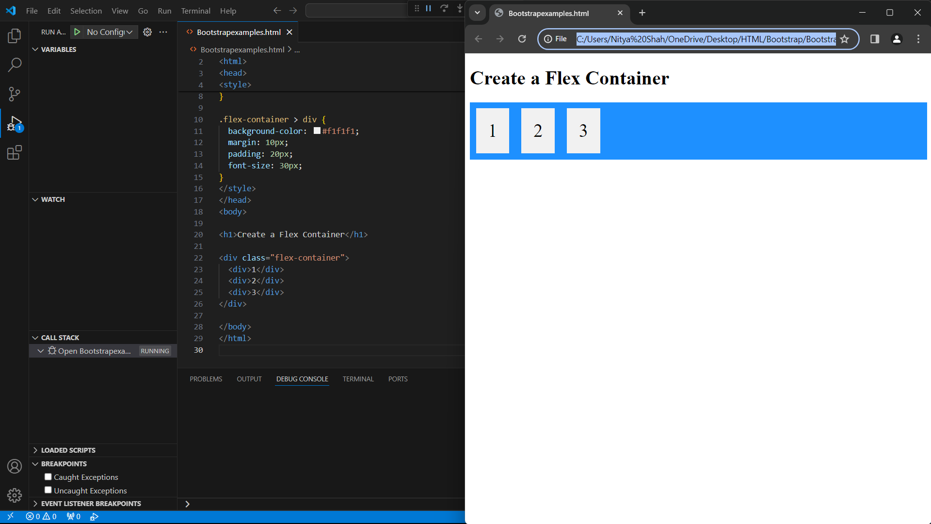

1. How can one create an alert in Bootstrap?

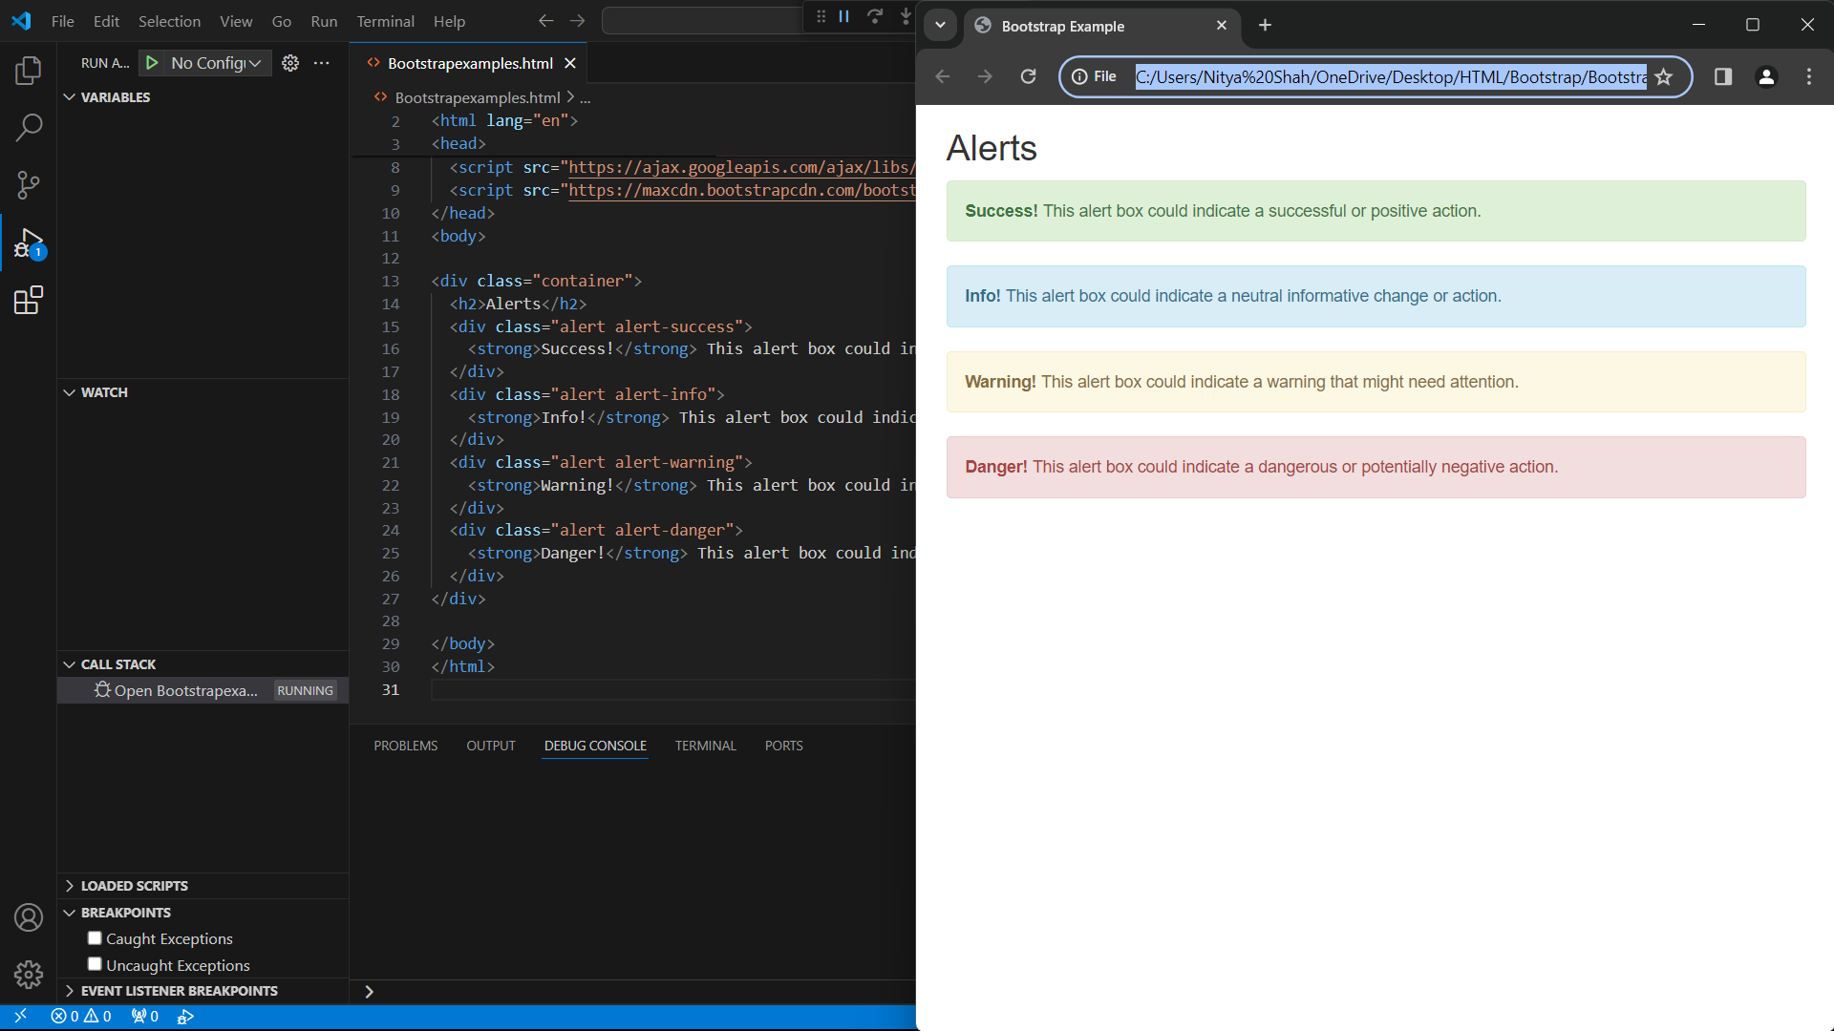

1. What is a bootstrap card and how would you create one?

* Bootstraps cards provide a flexible and extensible content containers with multiple variants and options.

